User Manual

Group 3 - Chess Game

Ethan, Victor, Megan, Matt

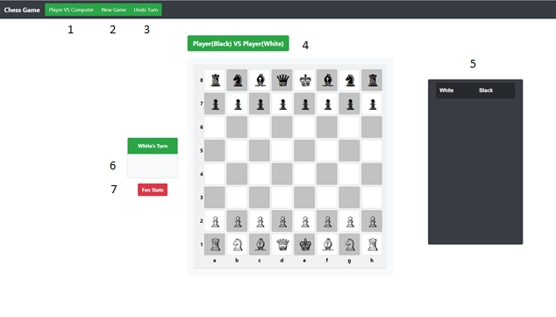 As seen below, Figure 1 shows the layout of the chess game. It is labeled from left to right, top to bottom. (1) shows the button that displays the current game mode and allows the user to change between player vs computer and player vs player. (2) is the button that creates a new game. (3) is a button that allows the user to undo a move. (4) shows the chess board. (5) is a table that displays all moves that have been taken during the game. (6) is an indicator that shows the user which player’s move it currently is, and if a player is in check. (7) is a button that shows or hides the table of moves.

Figure 1: The labeled state of the chess program at the start of a game.

During their turn, a player may click on any piece. When a piece is selected, valid moves are highlighted in blue, except for castling which is highlighted in purple. If a player is in check, selected pieces are highlighted in red to remind players that they must protect their king. Below, Figures 2-5 show these cases.

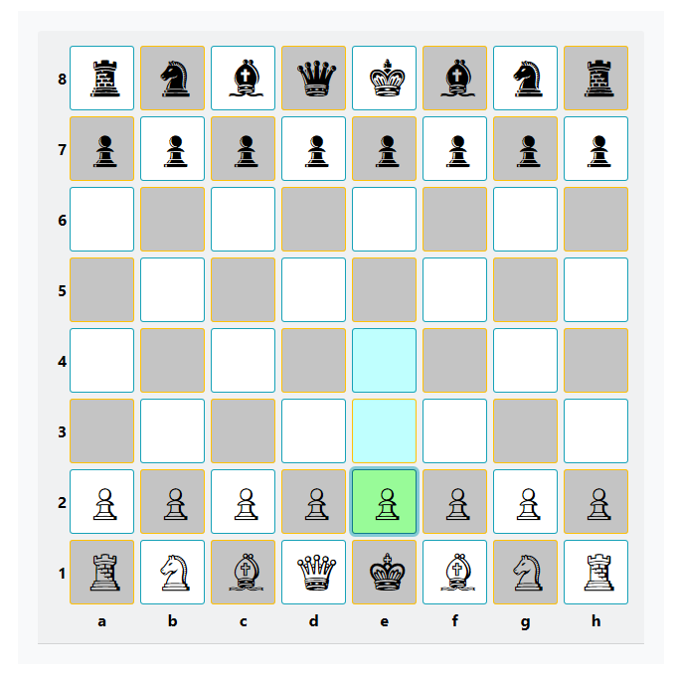Figure 2: When a chess piece is selected.

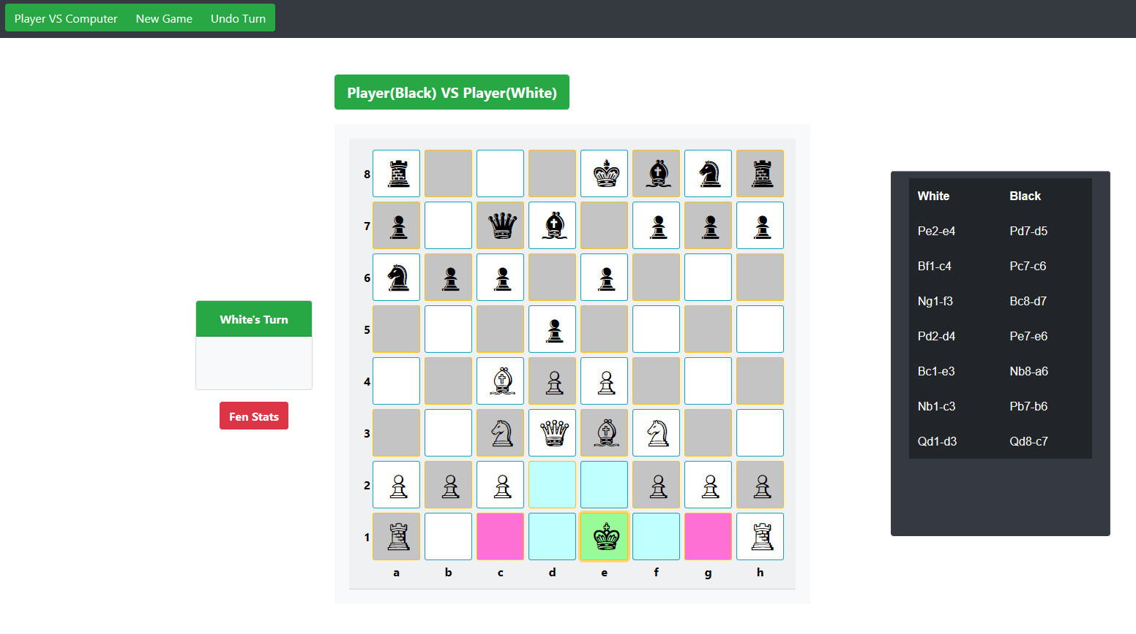Figure 3: When a player may castle.

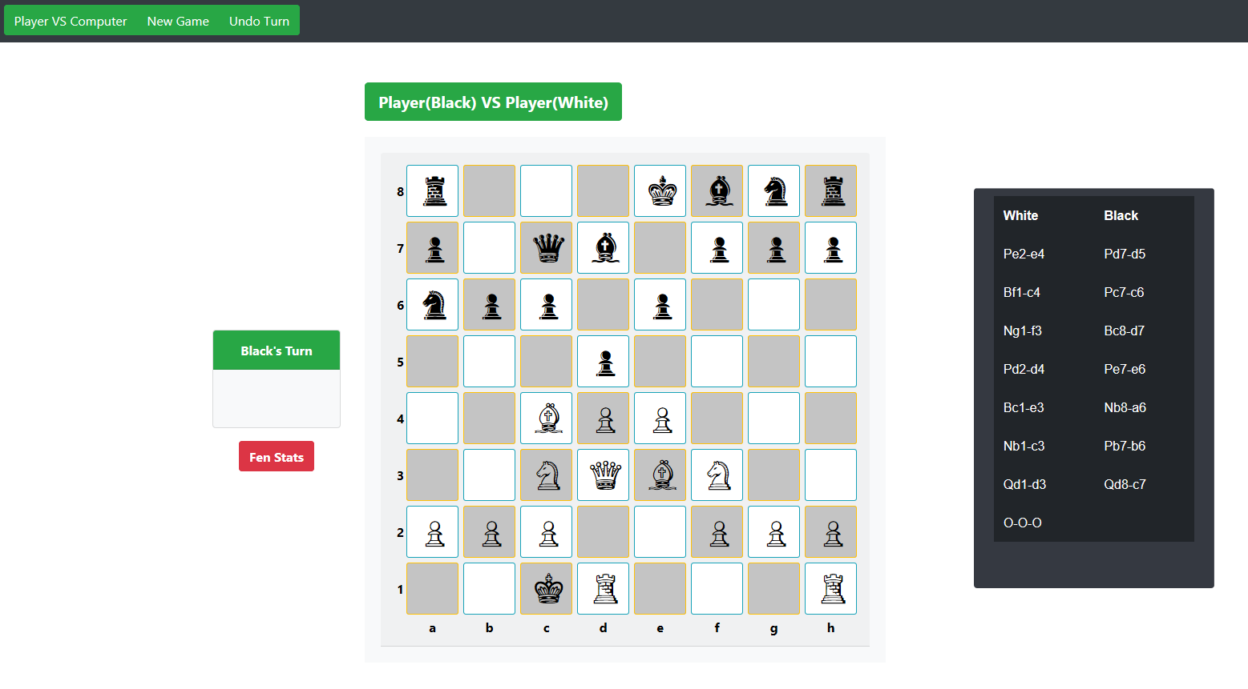Figure 4: After a player has successfully castled.

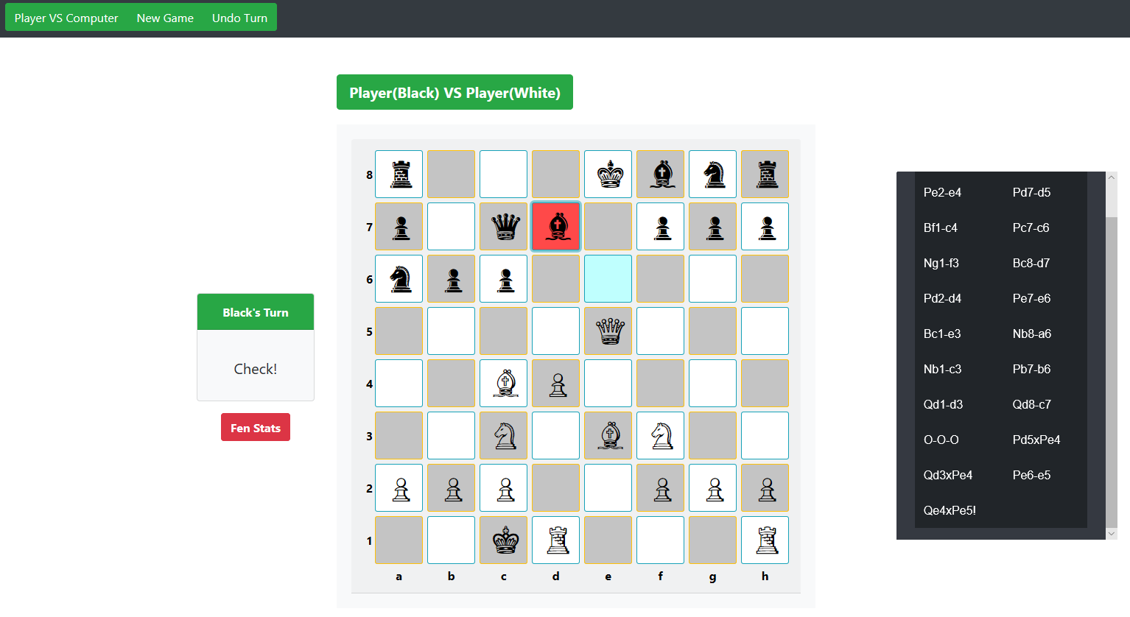Figure 5: When a player is in check.

When a pawn reaches the other end of the board, it may be promoted into another piece. The player may choose between a queen, bishop, rook, or knight. The upper left corner of the screen will show the options, and once the player clicks on one of them, the pawn will be transformed and play will resume. Figures 6 and 7 show pawn promotion.

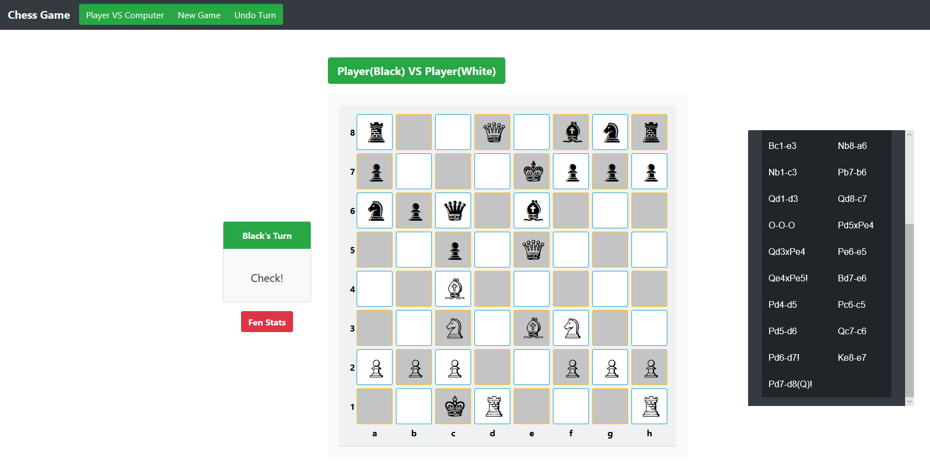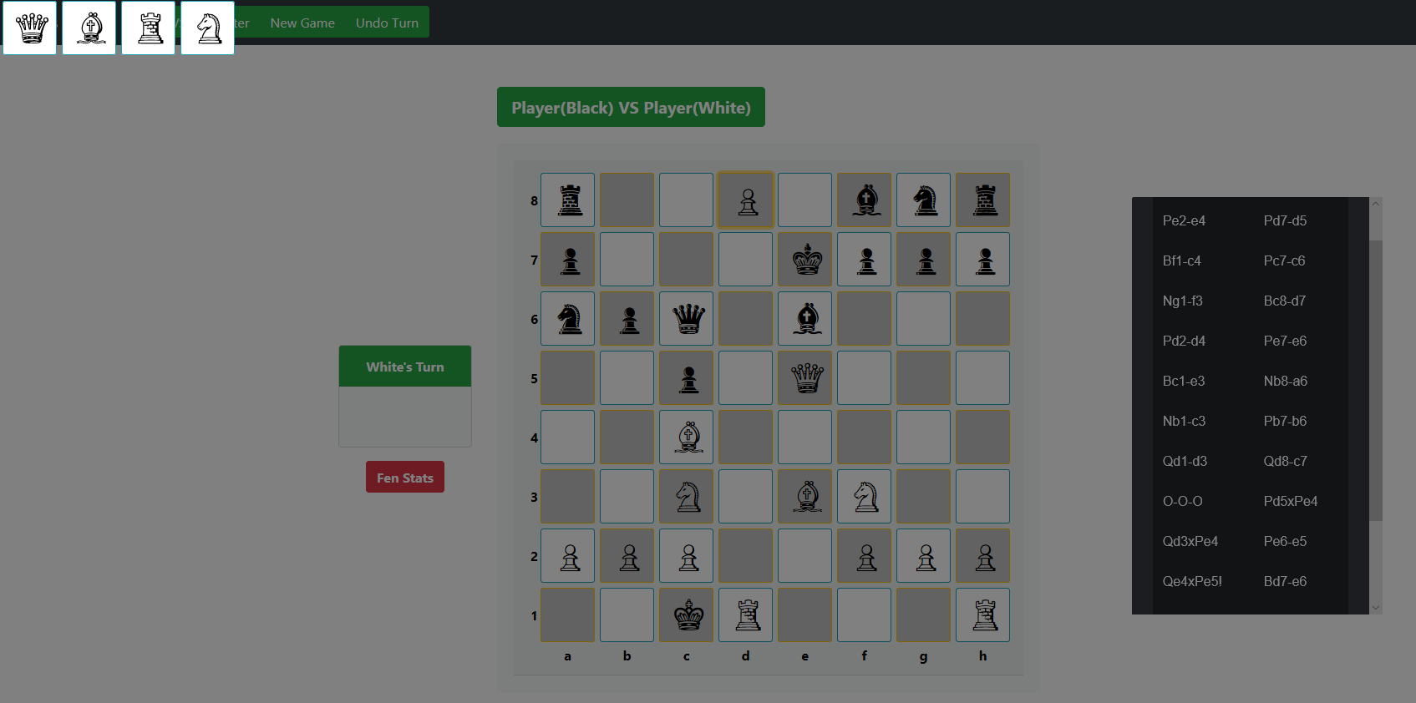Figure 6: Pawn promotion interface.

Figure 7: After pawn promotion.

Finally, the table showing the move history of the game uses reverse algebraic notation to denote moves. There are two columns in the table; white’s moves stored on the left and black’s moves are stored on the right. Each move contains the piece abbreviation followed by its previous square, a symbol noting movement and the new square the piece is located on. Piece abbreviations are: P for pawn, B for bishop, N for knight, R for rook, Q for queen, and K for king. Squares are denoted by their location on the board. For example, if the white king is on e1 and moves to d2, it would be shown as “Ke1-d2.” The symbol between the two squares is a dash to show a piece was moved normally or a cross to show the piece has captured an opposing piece with that move. There are also special notations that denote castling, check, checkmate, en passant and pawn promotion. After a player castles, “O-O” is displayed for king-side castles, while “O-O-O” is displayed for queen-side castles. When a piece puts the enemy king in check, an exclamation mark is placed at the end of the move notation. A hash symbol is used in the event a player is put into checkmate. En passant is denoted by “(e.p.).” Finally, when a pawn is promoted, the abbreviation of the chosen piece is placed in parenthesis after the ending square. Examples of all cases and moves can be seen in the above figures.